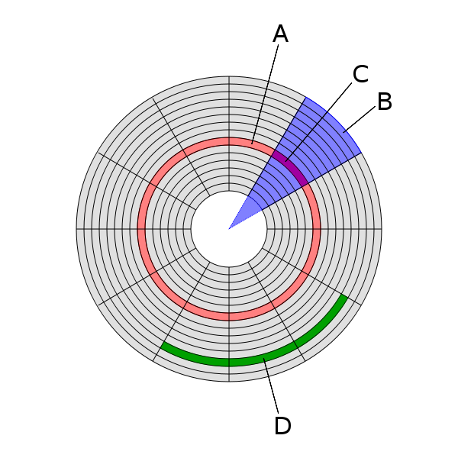

(A) Track  
(B) *Geometrical* **sector**  
(C) Track sector  
(D) [Cluster](https://en.wikipedia.org/wiki/Cluster_%28file_system%29)

**Number of Platters**

Hard disks can have one platter, or more, depending on the design. Standard consumer hard disks, the type probably in your PC right now, usually have between one and five platters in them. Some high-end drives--usually used in servers--have as many as a dozen platters. Some very old drives had even more. In every drive, all the platters are physically connected together on a common central spindle, to form a single assembly that spins as one unit, driven by the [spindle motor](http://www.pcguide.com/ref/hdd/op/spin.htm). The platters are kept apart using spacer rings that fit over the spindle. The entire assembly is secured from the top using a cap or cover and several screws. (See the [spindle motor page](http://www.pcguide.com/ref/hdd/op/spin.htm) for an illustration of these components.)

Each platter has two *surfaces* that are capable of holding data; each surface has a [read/write head](http://www.pcguide.com/ref/hdd/op/heads/index.htm). Normally both surfaces of each platter are used, but that is not always the case. Some older drives that use [dedicated servo positioning](http://www.pcguide.com/ref/hdd/op/act_Servo.htm) reserve one surface for holding servo information. Newer drives don't need to spend a surface on servo information, but sometimes leave a surface unused for *marketing reasons*--to create a drive of a particular capacity in a family of drives. With modern drives packing huge amounts of data on a single platter, using only one surface of a platter allows for increased "granularity". For example, IBM's Deskstar 40GV family sports an impressive 20 GB per platter data capacity. Since IBM wanted to make a 30 version of this drive, they used three surfaces (on two platters) for that drive. Here's a good illustration of how Western Digital created five different capacities using three platters in their Caviar line of hard disk drives:

|  |  |  |  |  |
| --- | --- | --- | --- | --- |
| **Model Number** | **Nominal Size (GB)** | **Data Sectors Per Drive** | **Platters** | **Surfaces** |
| **WD64AA** | 6.4 | 12,594,960 | 1 | 2 |
| **WD102AA** | 10.2 | 20,044,080 | 2 | 3 |
| **WD136AA** | 13.6 | 26,564,832 | 2 | 4 |
| **WD172AA** | 17.2 | 33,687,360 | 3 | 5 |
| **WD205AA** | 20.5 | 40,079,088 | 3 | 6 |

http://www.pcguide.com/note.gif**Note:** In theory, using only one surface means manufacturing costs can be saved by making use of platters that have unacceptable defects on one surface, but I don't know if this optimizing is done in practice...

From an engineering standpoint there are several factors that are related to the number of platters used in the disk. Drives with many platters are more difficult to engineer due to the increased mass of the spindle unit, the need to perfectly align all the drives, and the greater difficulty in keeping noise and vibration under control. More platters also means more mass, and therefore slower response to commands to start or stop the drive; this can be compensated for with a stronger [spindle motor](http://www.pcguide.com/ref/hdd/op/spin.htm), but that leads to other tradeoffs. In fact, the trend recently has been towards drives with *fewer* head arms and platters, not more. Areal density continues to increase, allowing the creation of large drives without using a lot of platters. This enables manufacturers to reduce platter count to improve seek time without creating drives too small for the marketplace. [See here for more on this trend](http://www.pcguide.com/ref/hdd/op/act_Arms.htm).

|  |
| --- |
| http://www.pcguide.com/ref/hdd/op/z_seagate_10platter.jpg |
| This Barracuda hard disk has 10 platters. (I find the choice of fish hooks as a background for this shot highly amusing. :^) ) |
| *Original image ©* [*Seagate Technology*](http://www.seagate.com) *Image used with permission.* |

The [form factor](http://www.pcguide.com/ref/hdd/op/form.htm) of the hard disk also has a great influence on the number of platters in a drive. Even if hard disk engineers wanted to put lots of platters in a particular model, the standard PC "slimline" hard disk form factor is limited to 1 inch in height, which limits the number of platters that can be put in a single unit. Larger 1.6-inch "half height" drives are often found in servers and usually have many more platters than desktop PC drives. Of course, engineers are constantly working to reduce the amount of clearance required between platters, so they can increase the number of platters in drives of a given height.

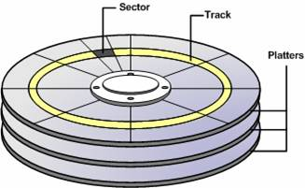

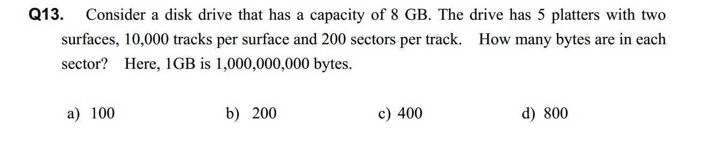

Answer: c

8 GB = 8 * 10^9

5 platters with two surfaces = 5 * 2 = 10

Number of bytes in each sector = (8 * 10^9) / (10 * 10000 * 200) = 400